**MSS60**

**Module description**

**Moment Management**

Change documentation from r300 4

1. Overview Moment Manager 5

2. Calculation of base sizes 8

2.1. Moment Calculation 8

2.1.1. Calculation of Lambda efficiency 12 12

3. Moment Interface ( CAN ) 13

3.1. Interface to climate control and KSG 13

3.2. Interface to ASC/DSC - Request moment intervention 14

3.3. Interface to ASC/DSC - Feedback Moment Intervention 15

4. Friction torque 16

5. Towing moment 17

6. Maximum indexed moment 19

7. Calculation of desired moment 20

8. Moment filter 21

8.1. Dynamic filter for desired moment gradients 22

8.1.1. Load impact filter 25

8.1.2. Dashpotfilter 25

8.2. Intervention idle controller 26

9. Moment Limits 26

9.1. Torque limitation 27

9.2. Speed limit 28

9.3. Torques for cat-damaging dropouts 29

9.4. Torques at the breakdown of the krafstoff druck 29

9.5. Moment limitation for noise reduction 29

10. Moment reserve 30

10.1. Moment reserve for cather function 30

10.2. Moment reserve for strong steering impacts (not implemented in EVT!) 32

10.3. Limitation of moment reserve 32

11. Moment intervention Filling path 33

11.1. Efficiency Correction 34

11.2. Calculation of wi 34

12. Calculation of control edges 35

13. Moment intervention ignition path 35

14. Calculation of ignition angle interference 36

14.1. Calculation of Optimal ignition angle 36

14.2. Calculation of ignition angle efficiency 37 37

14.2.1. minimum ignition angle efficiency 38

14.2.2. Base ignition angle efficiency 38

14.2.3. Calculation of ignition angle efficiency before intervention 38

14.2.4. Calculation of ignition angle efficiency after intervention 38

14.2.5. Calculation of interference ignition angle 39

14.3. Calculation Standardized ignition hooks 41

15. Monitoring Moments Calculation 43

15.1. Hedging Moment Calculation 43

15.2. Monitoring Target moment to actual moment 43

15.2.1. Monitoring of target/actual moment over entire operating range 44

15.2.2. Monitoring target/actual moment at PWG specification = 0 44

15.3. Partial firing for open clamping throttles 45

16. Applicationable data from the Moment Manager 46

17. Variables of the Moment Manager 49

# Change documentation from r300

|  |  |  |
| --- | --- | --- |
| **Version** | **Date** | **Comment** |
| S300 | 1.6.2004 | Acquisition from MSS60 project |
| S310 | 2.10.2004 | Overview image for EVT filling control changed and module control edges added |
| S320 | 16.11.2004 | Document rough (due to lack of time due to software requirements) revised  Ignition angle angle angle degree in the SW temporarily set to 100% |
| S330 | 1.12.2004 | Consumption moment in generator operation of the KSG included in the moment structure |
| S330 | 1.12.2004 | Calculation wi of mode manager misplaced in the moment manager |
| S350 | 13.2.2005 | Document completely revised again |
| S360 | 10.3.2005 | B_EVT removed as only EVT motors are still operated |
| S370 | 4.7.2005 | Complete moment change of the desired moment to negative range |
| S370 | 6.7.2005 | Complete conversion of the LS/Dashpot filter and removal of the SA/WE filter |
| S370 | 30.08.2005 | rm : Calculation ignition angle intervention / ignition hook |
| S370 | 11.9.2005 | Actual moment calculation changed |
| S370 | 18.9.2005 | Moment calculation from HFM signal (according to Spec. by F. Mayer) |
| S380 | 5.11.2005 | Dynamic filter expanded by two areas |
| S380 | 5.11.2005 | Clearing of idle controller adaptation md_llra is now subtracted instead of added |
| S380 | 16.11.2005 | Invoice of md_e_verbraucher completely changed |
|  |  |  |
|  |  |  |

# 1. Overview Moment Manager

With the conversion of all motor torque interventions ( ASC/DSC, EGS, IHKA ) to a standardized torque interface, a central coordination of all moment requirements for the filling and ignition path became necessary. This task is to be taken over by the Moment Manager.

The following list should give a quick overview of the individual modules of the moment manager or very closely linked modules. For the sake of clarity, the description is reduced to a core set and is limited as input or output variables only for the sequence of the moment calculation of the most important quantities.

**Module: Pedal value acquisition**

Determination of the relative driver's wish moment

Input sizes: pwg1, pwg2, n, S_FDYN

Output sizes: pwg_soll

**Module: minimum moment**

Determination of the minimum indexed motor torque

Input sizes: n, zustand_motor, md_llra, md_reib_filter, md_e_verbraucher

Output sizes: md_e_schlepp, md_e_schlepp_hyp

**Module: maximum moment**

Determination of the maximum indexed motor torque

Input sizes: n, md_e_schlepp, rf_pt_korr, md_fw_rel

Output sizes: md_e_max

**Module: Consumers**

Identifying consumer moments

Input sizes: can_kkos_lm, md_ksg, S_KO

Output sizes: md_e_verbraucher

**Module: Friction torque**

Determination of the friction torque of the motor

Input sizes: n, tmot, toel

Output sizes: md_reib_filter

**Module: Calculation of driver's desired moment**

Determination of the absolute driver's wish moment incl. FGR

Input sizes: md_fw_rel, md_ind_fgr, b_fgr_aktiv, md_e_schlepp_hyp

Output sizes: md_e_fw, d_md_wunsch_rel

**Module: Dynamic Filter**

Filtering Driver's Wish Moment

Input sizes: md_e_fw, sa_we_st, dyn_st, gang, md_e_schlepp

Output sizes: md_fw_filter, md_sawe_filter, md_ind_wunsch

**Module: Intervention idle control**

Consideration of I-part of the idle control

Input sizes: md_ind_wunsch, md_llri

Output sizes: md_ind_wunsch_filter (actually name is not correct)

**Module: Vmax control**

gang-dependent Vmax limitation

Input sizes: v_antrieb, d_v, gang

Output sizes: md_ind_vmax, vmax_st

**Module: Torque limitation**

Torque limitation

Input sizes: gang, B_Kraftschluss, d_n, md_ind_schlepp, md_eta_zw_ve

Output sizes: md_max_begr, md_begr_st

**Module: Moment Limit**

Coordination of torque limits

Input sizes: md_ind_vmax, vmax_st, md_max_begr, md_sk_begr, sk_egas_zustand, n, d_n_segment, gang

Output sizes: md_ind_wunsch_begr

**Module: Moment Reserve**

Building a moment reserve for cat heating

Input sizes: kath_zustand, n, wi, tmot, t_ml

Output sizes: md_res

**Module: DSC intervention**

Moment interventions of the DSC system into the filling path

Input sizes: asc_st, md_ind_asc, md_ind_msr

Output sizes: md_ind_asc_abs, md_ind_msr_abs

**Module: Conversion into filling by control edges**

Conversion of the moment specification into control edges, basic throttle angle

Input sizes: wi, n, rf_pt_korr

Output sizes: ao_aw, as_aw, eo_aw, es_aw, ml_soll_bas, wdk_soll_evt, ti_ende_evt

**Module: Moment interference ignition angle**

Coordination of moment interventions in the ZW path

Input sizes: md_ind_wunsch_begr, md_llr_tz, md_ind_asc_abs, md_ind_msr_abs

Output sizes: md_tz_red

**Module: Calculation ZW intervention**

Calculation of an absolute ignition angle based on the moment specification and the actual torque of the engine

Input sizes: md_tz_red, md_ind_opt_korr, md_eta_zw_min, n, wi

Output sizes: tz_md[x]

**Module: Calculation Basic Sizes**

Module for calculating the different actual moments and ZW efficiencies, as well as all auxiliary variables for the moment calculation and coordination

**Module: standardized moment interface**

Implementation of the standardized torque interface as well as the air-conditioning compressor connection according to CAN-Load Heft 11H

**Picture: Overview Moment Manager (mm.gif)**

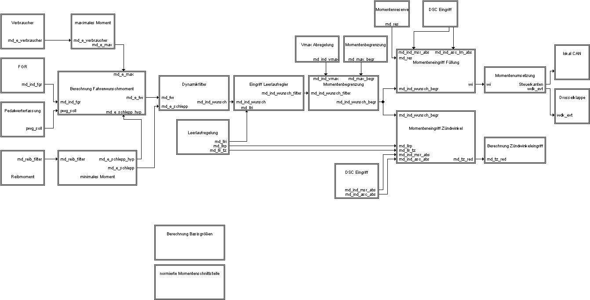

# 2. Calculation of basic sizes

A main component of the moment manager is the determination of the actual moments before and after moment interventions, the optimal ignition angle, as well as the calculation of the efficiencies of lambda and ignition angle corrections. The calculation of the individual quantities is summarized in the module "Calculation Basic Sizes".

The indexed actual moment corresponds to the moment that is attached to the coupling and the friction. In order to make the switching on or off of consumers (or disturbances) moment-neutral, the actual moment is first calculated. It is a polished delayed wi target set, which is based on data being removed.

## 2.1. Moment Calculation

**corrected maximum actual wi "md_wi_opt_korr"**

The corrected maximum indexed actual wi "md_wi_opt_korr" takes into account the lambda influence on the generated motor torque. It corresponds to the actual moment "md_wi_ind_opt_th", corrected by the current lambda efficiency "md_eta_lambda".

md_wi_opt_korr = md_wi_ind_opt_th * md_eta_lambda

**actual actual moment before moment interventions "md_ind_ve"**

The moment "md_ind_ve" represents the actual actual moment of the engine, which it would deliver without ignition angle interference of the moment manager. However, the moment reductions caused by ignition angle interventions by other modules such as knock control, cat heating, etc. are taken into account. This takes the form of an ignition angle efficiency "md_eta_zw_ve", the calculation of which is also described in this chapter.

md_ind_ve = (md_wi_opt_korr * md_eta_zw_ve) * K_RF_HUBVOLUMEN / 0.012566

**actual actual moment after moment interventions "md_ind_ne"**

The moment "md_ind_ne" represents the actual moment of the motor generated, taking into account all moment interventions. For this purpose, an ignition angle efficiency "md_eta_zw_ne" is taken into account, which also includes the ignition interventions of the moment manager.

md_ind_ne = (md_wi_opt_korr * md_eta_zw_ne) * K_RF_HUBVOLUMEN / 0.012566

**Picture: Calculation Actual Moments (md_ist.gif)**

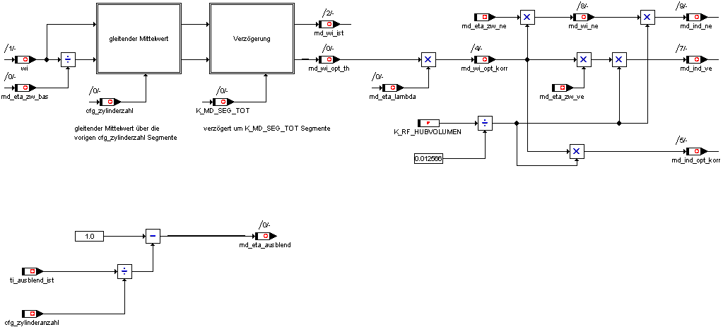

**Description of the actual moment calculation**

The target target "wi" is delayed by the applicationable segment counter K_MD_SEG_TOT corresponding to the segment dead time. This size is also ground with the wi calculated for the last "cfg_zylinderzahl" segments. The resulting size "md_wi_ist" corresponds stationary to the "wi" driven out at the test bench, which in some places is knock-limited or contains an ignition angle hold (in the idle area). The theoretical best value of the ignition hook "md_wi_opt_th" is determined with the efficiency "md_eta_zw_bas". The lambda influence is taken into account in the size "md_wi_opt_korr". Subsequently, the current "md_wi_ne" is calculated with the efficiency "md_eta_zw_ne" after all ignition angle interventions and with lambda influence. Md_eta_ausblend has not been used to calculate "md_ind_ne" (md_wi_ne) since S370, because incorrect values would be calculated in the case of cylinder shutdown.

md_eta_zw_bas: Efficiency pre-steer ignition angle (applied in the characteristic field) md_zw_opt_korr to theoretical ignition angle without knock limitation and torque retention, since the theoretical best ignition angle is changed temperature-dependent and lambda-dependent, the pre-control ignition angle should be changed with the physically similar facial expressions

md_eta_zw_ne: Efficiency of current ignition angles to theoretical best ignition angle without knock limitation

md_eta_lambda: Efficiency Influence Lambda (Vollast, Component Protection, ...)

*Delayed and polished wi:*

by K_MD_SEG_TOT segments (180 degrees at 4 cylinders) delayed wi and moving average over the previous cfg_zylinderzahl segments.

Example: cfg_zylinderzahl = 4, K_MD_SEG_TOT = 5

Target specifications : wi(1) wi(2) wi(3) wi(4) wi(5) wi(5) wi(7) wi(8) wi(9) wi(10)

Actual moment in the 10th segment: md_wi_ist(10) = (wi3+wi4+wi5+wi6)/4

**Actual moment calculation from HFM signal**

**Physical background**

In order to be able to make defined moment interventions, the currently set motor torque must be available in the functional structure. The air mass sucked in by the engine is under the boundary conditions optimal ignition angle and Lambda = 1 directly proportional to the engine torque. Taking into account efficiency interventions, the motor torque can thus be deposited in a characteristic field via speed and air mass and made available to the functional structure.

**Picture: Calculation Actual Moments (md_ist_hfm.gif)**

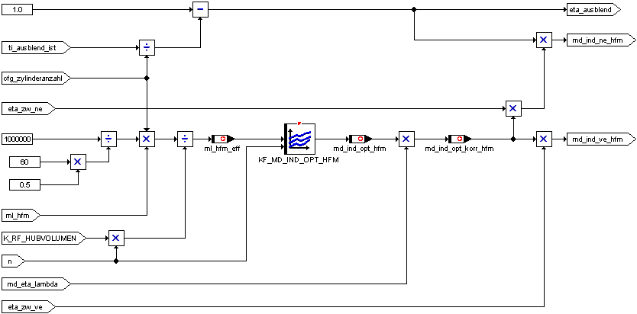

**Optimal indexed actual moment from hfm**

The optimal indexed actual moment md_ind_opt_hfm is the moment that the motor generates at the operating point with optimal ignition time and lambda = 1. The actual moment was determined on the test bench depending on the speed and the air mass measured by the HFM, per working play and cylinder in relation to the cylinder stroke volume, and stored in the characteristic field KF_MD_IND_OPT_HFM.

(1) md_ind_opt_hfm = KF_MD_IND_OPT_HFM(s, ml_hfm_eff)

**corrected optimal indexed actual moment from hfm**

The corrected optimal indexed actual moment md_ind_opt_korr_hfm takes into account the lambda influence on the generated motor torque. It corresponds to the actual moment md_ind_opt_hfm, corrected by the current lambda efficiency md_eta_lambda.

(2) md_ind_opt_korr_hfm =md_ind_opt_hfm * md_eta_lambda

**actual actual moment before moment interventions from hfm**

The moment md_ind_ve_hfm represents the actual moment of the engine, which it would deliver without ignition angle interference of the moment manager. However, the moment reductions caused by ignition angle interventions of other motor modules such as knock control, cat heating, etc. are taken into account. This takes the form of an ignition angle efficiency eta_zw_ve (see chap. 1.1.2.4 "Calculation of ignition angle interventions").

(3) md_ind_ve_hfm =md_ind_opt_korr_hfm * md_eta_zw_ve

**actual actual moment after moment interventions from hfm**

The moment md_ind_ne_hfm represents the actual moment of the motor, taking into account all the moment interventions. For this purpose, an ignition angle efficiency eta_zw_ne is taken into account, which also includes the ignition interventions of the moment manager (Ch. "Calculation of ignition angle intervention"). Furthermore, injection fades of individual or all cylinders in the form of a fade-effect eta_ausblend are also included.

(4) md_ind_ne_hfm = md_ind_opt_korr_hfm * md_eta_zw_ne * md_eta_ausblend

### 2.5. Calculation of Lambda efficiency levels

In addition to the ignition angle, the lambda ratio also has an influence on the indexed engine torque. All moment characteristics have been determined for a lambda of 1.0. In real motor operation, the actual lambda ratio must be determined and the corresponding actual and target moments corrected with a correction factor.

In the lambda-controlled range, Lambda is always one and thus also the correction factor equals 1.0. In full load operation, the lambda value is taken from the "KF_MD_MAX_LA_VL" characteristic field and converted into a correction factor via the "KL_MD_MAX_MD_LA" characteristic.

With inactive lambda control (e.g. during warm-up ) lambda values can also exist unequal one due to the mixture­pre-control, which must be taken into account in the moment path. For this purpose, the lambda value valid for the operating point must be stored in the "KF_MD_LAMBDA" characteristic field.

Mixture emaciations during the warm-up phase are taken into account by dividing the lambda value from the characteristic curves by the weight loss factor "ti_f_md". Mixture grease (ti_f_md > 1) || (ti_f_md < 0.5) are not corrected.

For completeness, the following graphic also includes the calculation of "md_eta_lambda". This offset ignition angle reflects the influence of the lambda value on the optimal ignition angle.

**Picture: Calculation Lambda efficiency (lambda efficiency.gif)**

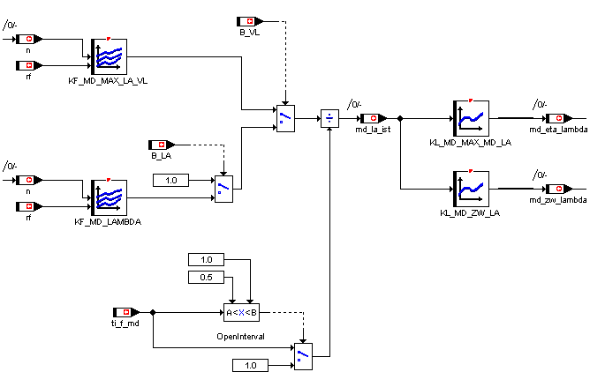

# 3. Moment Interface ( CAN )

The Moment Manager currently has three interfaces via CAN to other systems.

## 3.1. Interface to climate control and KSG

In the "can_kkos_lm" signal, the climate control system transmits the current power consumption of the air conditioning compressor. This moment of loss must be taken into account by the moment manager in the form of a consumer moment "md_e_verbraucher" in the calculation of the driver's desired moment. Since the moment request and actual moment requirement do not always exactly match, the difference is compensated by the idle control by means of a moment adaptation.

When recognizing a moment requirement of climate control for the first time, the requested moment (sum of climate requirement plus adaptation ) is weighted with the factor "K_MD_MIN_KKOS_START", whereby this factor can also become greater one, which is equivalent to an initial value increase. This initial value is then passed on to the requested value via a PT1‑filter with the time constant "K_MD_MIN_KKOS_FILTER". When the air-conditioning compressor is switched off, the loss moment is adjusted to zero with the filter time constant "K_MD_MIN_KKOS_AUS_FILTER".

In addition, the filtered moment is added by the KSG "md_ksg_filter" in generator mode and at switching position of "B_EVT_STATE_MAN"(= 3 or 4). "Md_ksg" is transmitted to the motor control via local CAN. The pt1 filtering of "md_ksg" can be influenced with the time constant "K_MD_MIN_KSG_FILTER".

**Picture: Calculation Moment of Loss (md_verbraucher.gif)**

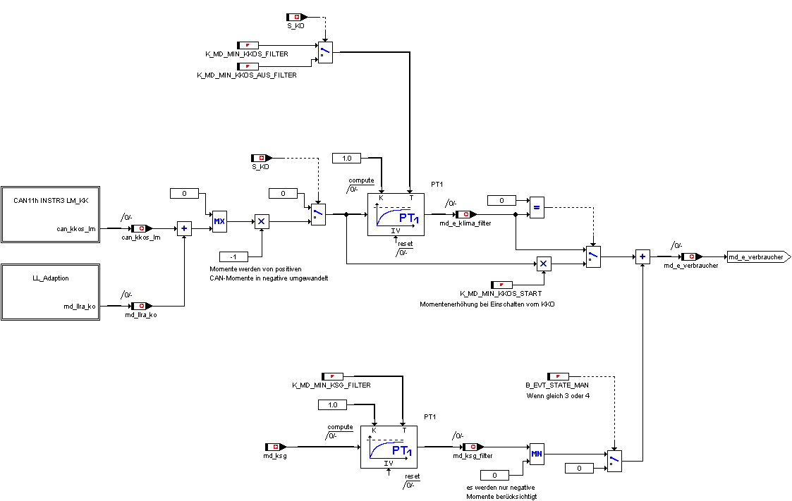

## 3.2. Interface to ASC/DSC - Request Moment Intervention

The ASC or DSC control unit is able to influence the indexed motor torque by means of a normalized moment interface. Three paths are provided for possible interventions.

- md_ind_asc_lm: moment reduction by reducing the filling

- md_ind_asc: Torque reduction via an ignition angle late adjustment

- md_ind_msr : increase in torques by increasing the filling

All moment requests are related to an indexed standard moment "K_MD_NORM", the value range is between 0% and 99.6%.

The interventions of the ASC/DSC system can be blocked by means of the application constant "K_MD_ASC_CONTROL".

Bit 0 = 1 : ASC intervention blocked (entspr. B_ASC_EINGR_ENABLE = 0)

Bit 1 = 1 : MSR intervention blocked (entspr. B_MSR_EINGR_ENABLE = 0)

The MSR intervention is limited to the "K_MD_MSR_BEGR" moment.

**Image: Interface ASC/DSC (asc_dsc.gif)**

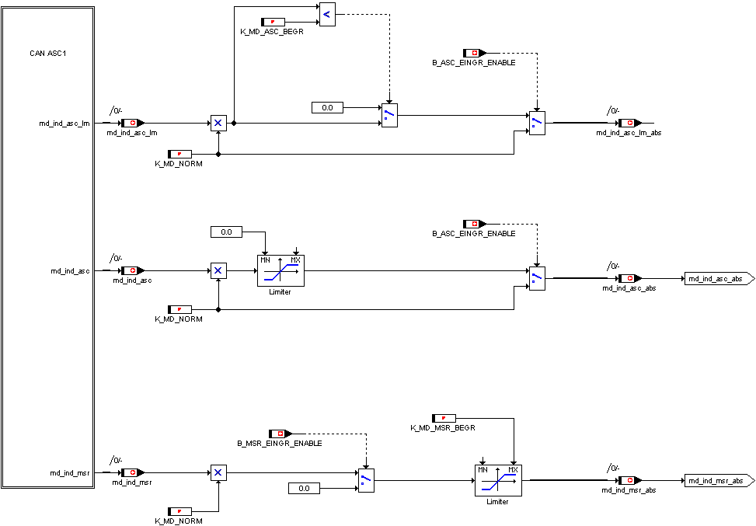

## 3.3. Interface to ASC/DSC - Feedback Moment Intervention

The DME returns the following moment to the DSC:

- md_norm_can : reference torque for all moment data

- md_reib_can: loss moment of the engine incl. all consumers

( alternator, oil pump, air-conditioning compressor, ... )

- md_ind_ist : generated indexed actual moment of the motor without taking into account

of DSC interventions

- md_ind_ne_ist: generated indexed actual moment of the motor taking into account

of all interventions

- md_ind_lm_ist: theoretical motor torque calculated from the measured

Air mass without taking into account external ignition angle interventions

Since the MSS60 does not distinguish between internal and external ignition angle interventions, the calculation of "md_ind_lm_ist" is not so easy. If no external ZW intervention is active, the moment "md_ind_ne" is used as "md_ind_lm", which also takes into account all internal ZW‑interventions. If, on the other hand, an external ZW intervention ( ASC, MSR ) is active, "md_ind_ve" is used, which includes the internal ZW influences from base ignition angle, knock control, knock adaptation and dynamic retention.

**Picture: Feedback to DSC (rueckmeldungdsc.gif)**

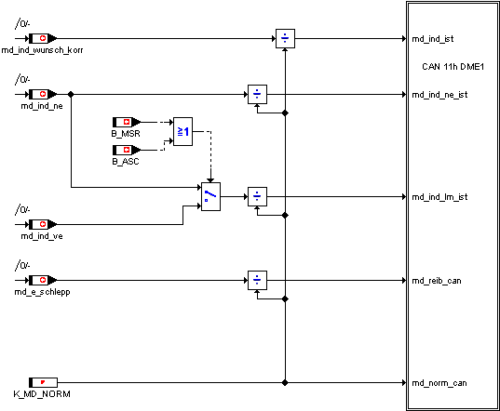

# 4. Friction moment

The friction moment is the moment needed to turn the engine unfired.

The friction curve is driven out under defined conditions "KF_MD_MIN_REIB_NORM". Deviations from these standard conditions are taken into account in "KF_MD_MIN_REIB_DIFF". The "KL_MD_MIN_REIB_OFFSET" and "KL_MD_MIN_REIB_ABREG" characteristics take into account the additional moment requirement at the start, which is regulated.

In the "KF_MD_MIN_REIB_NORM" characteristic field, the friction curve is determined at "tmot"=80 °C and "toel"=80 °C and closed valves. The torque required to hold the valves is stored in the "KL_MD_KSG_VENT_HALT" characteristic. "Md_min_reib_norm_mech" is the towing torque of the motor at defined temperatures without the electrical friction portion of the valve drive.

Deviations from the standard temperatures are taken into account in the "KF_MD_MIN_REIB_DIFF" characteristic field (negative values at colder temperatures, positive values at warmer temperatures).

In order to meet an increased moment requirement of the motor in the start and in the first seconds afterwards, the towing torque during the start is increased by the offset "md_reib_offset" (KL_MD_MIN_REIB_OFFSET = f ( tmot )), which is adjusted to zero after completion of the post-start with the moment ramp "KL_MD_MIN_REIB_ABREG" = f ( tmot ).

**Picture: Calculation of friction moment (md_reib.gif)**

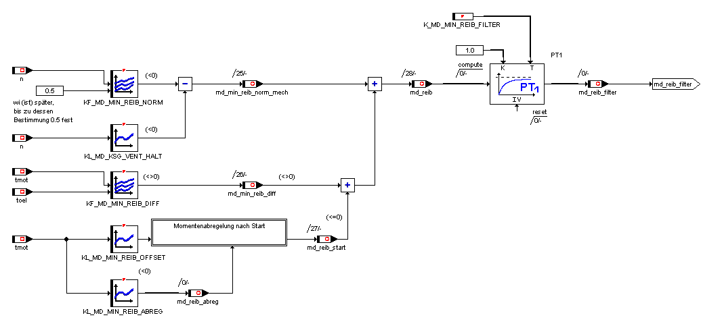

# 4. Towing moment

The towing moment is the minimum torque that can be requested by the motor controller. It includes the temperature-dependent basic friction of the engine. Other sizes are charged in it.

The towing moment on an effective basis is calculated twice. Together, the friction moment "md_reib" is filtered via a PT1 filter and the moment is subtracted from the idle slider adaptation "md_llra". The differences are as follows:

With "md_e_schlepp_hyp" the moment of the maximum possible charge change losses is added "KL_MD_LW_MIN". The sum is then multiplied by a hyperbolic function to increase the towing torque at low speeds (at idle speed to zero effective moment). Also, the moment can be changed manually by the characteristic "KL_MD_MIN_FAK_MAN_LLR" in order to achieve an increase in the range of low speeds.

With "md_e_schlepp" the additional torque required for the start case "md_min_start" is added, which is speed and tmot-dependent.

In the "KF_MD_MIN_START" characteristic field, additional torque values are applied for the start case, which depend on the speed and cooling water temperature. Different from each other, the following sizes are charged. In the characteristic "KL_MD_LW_MIN" the torque values, which are additionally achievable with maximum possible charge change losses, are stored above the speed. Such heavy losses are generated by letting the engine compress the cylinder volume and then opening the valves to avoid using expansion energy.

To calculate "md_e_schlepp_hyp" "md_temp3" in the low speed range is multiplied by a hyperbolic function ("md_min_fak_man_llr"), which raises the torque at idle speed to zero effective moment. In the hyperbolic function, the current speed, the idle target speed and the factor "n_hyp" are calculated. For this one:

n_hyp =lfr_nsoll + KL_MD_MIN_DN_HYP( tmot )

The weighting factor is calculated as follows:

md_min_fak_hyp_llr = 1 - [ ( n - n_hyp ) / ( n_ll - n_hyp ) * ( n_ll / n ) ]

The characteristic "KL_MD_MIN_DN_HYP" can be used to influence the steepness of the hyperbole. High values mean a flat hyperbole, low values a steep hyperbole. Also, the moment can be changed manually by the characteristic "KL_MD_MIN_FAK_MAN_LLR" in order to influence with great flexibility, for example, the torque gradient in the range of idle speed.

**Picture: Calculation drag moment (md_schlepp.gif)**

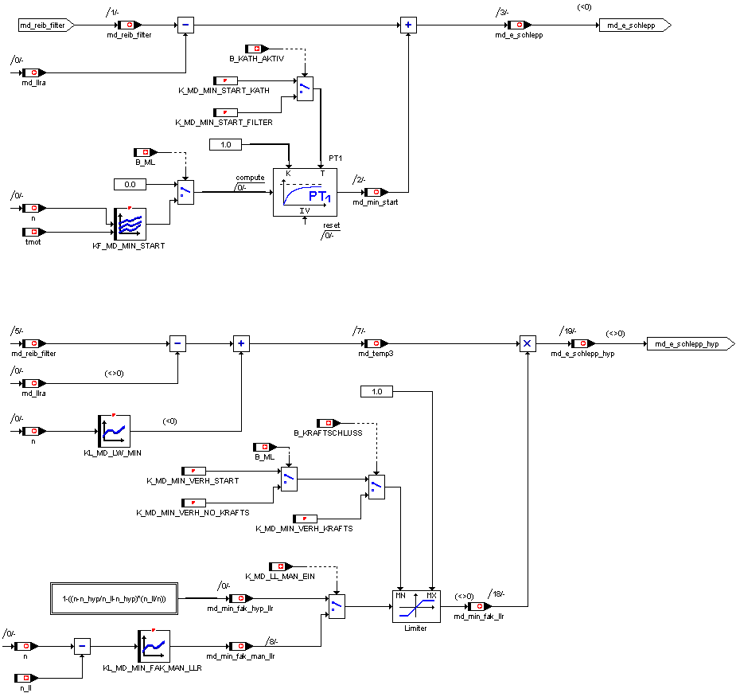

# 5. Maximum indexed moment

In the characteristic "KL_MD_WI_MAX_VL" the maximum "wi" is stored, which the motor can achieve in full-load operation and under standard conditions, full-load lambda and ignition optimum at the respective speed. By correcting to the real environmental conditions, you get the maximum "wi_max" currently possible.

The indexed work calculates the indexed moment. With this, the towing torque including the consumer "md_e_schlepp" and "md_e_verbraucher" is added, so that the effective maximum torque "md_e_max" is created. The addition of the consumption moments is weighted by the characteristic "KL_MD_KORR_VERBRAUCHER"=f(md_fw_rel). For small pedal positions up to approx. 80%, consumers are not included. Only then will a full accounting be obtained up to 100%. This avoids an empty path in the pedal at full load.

"Md_e_verbraucher" is the input size that takes into account all consumers as well as the KSG moment, which provides the current for the valve control, among other things.

**Picture: Calculation maximum effective moment (md_max.gif)**

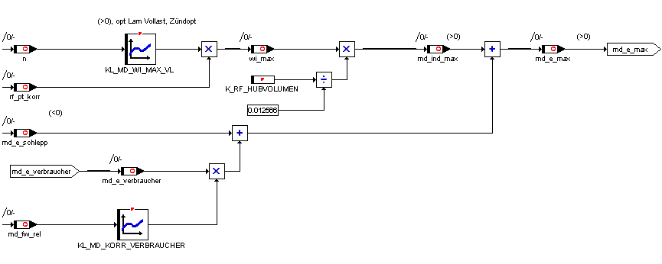

# 6. Calculation of desired moment

The driver's request is determined by the PWG module in the form of a relative pedal position "pwg_soll", where0% corresponds to an unoperated accelerator pedal, 100% to the full load stop of the pedal. This relative pedal position is converted via the "KF_MD_FAHRER" characteristic field into a relative driver's request "md_fw_rel", which in turn is between 0 and 100%. 100% corresponds to the maximum effective moment "md_e_max". 0% corresponds to the towing moment with hyperbolic elevation "md_e_schlepp_hyp" (without consumer).

At the same time, a relative moment request "md_ind_fgr" can also be determined by the module speed controller.

Subsequently, the "md_e_fw" effective driver's desired moment is determined with the addition of "md_e_schlepp_hyp".

**Picture: Calculation of the driver/FGR moment (md_fw.gif)**

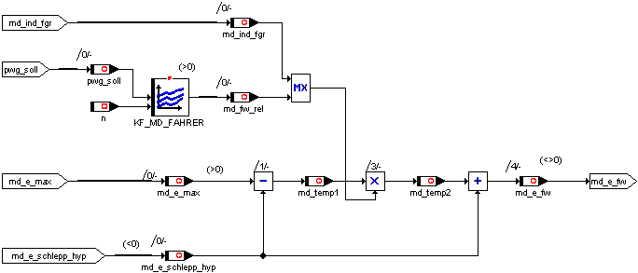

# 7. Moment filter

The dynamic filter is responsible for filtering the moment requirements in specific states and thus limiting the gradients.

The load impact/dashpot filter takes over the filtering of the driver's desired moment "md_e_fw". Depending on the operating point, a maximum allowed positive ( load impact ) or negative ( dashpot ) moment change per unit of time is calculated and the moment requirements of the driver or FGR are limited to these gradients.

The filtered driver's request moment "md_e_fw_filter" is then subtracted with the towing moment "md_e_schlepp" and the consumer moments "md_e_verbraucher" and stored in "md_ind_wunsch".

**Picture: Overview Moment Filter (md_filter.gif)**

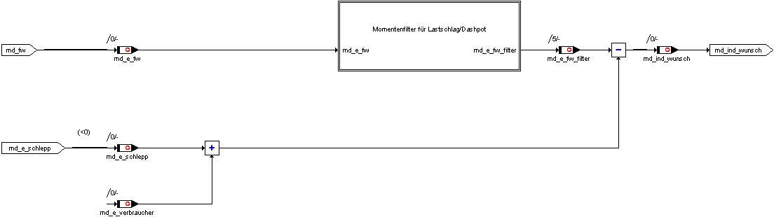

## 7.2. Dynamic filter for desired moment gradients

The dynamic filter becomes active for attenuating large positive (load impact) and large negative ( dashpot ) torque gradients.

Load impact and dashpot filters are similarly constructed. In principle, they differ only in the direction of the moment gradient:

Load impact : positive moment gradient

Dashpot : negative moment gradient

The dynamic filter can be switched on and off by means of the application constant "K_MD_DYNFIL_EIN". If you are stationary, the dynamic filter does not work (md_dyn_status = 0).

In the case of control, there is an applicable threshold value "K_MD_DYNFIL_AUF_12" for the torque, in which switching from area 1 to range 2. If another threshold "K_MD_DYNFIL_AUF_23" is exceeded, the switch to area 3.

The time-dependent increment is taken from a speed- and gear-dependent characteristic field depending on the range. Note that in the range 2 flatter ramps are applied to minimize tilting of the motor in the area of the effective moment=0. In areas 1 and 3, steeper ramps are applied.

In the case of control, there are similarly three ranges and two threshold values "K_MD_DYNFIL_AB_12" and "K_MD_DYNFIL_AB_23".

**Picture: Overview Dynamic Filter (md_filter_dyn.gif)**

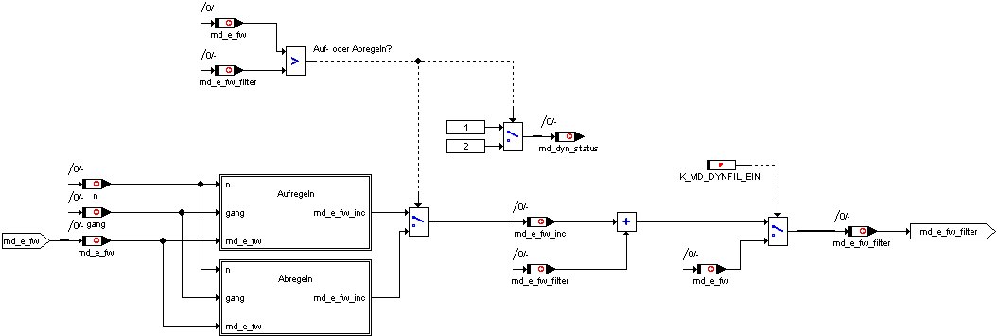

The "md_e_fw_inc" moment increment, which increments the new filtered driver's request, is calculated as follows:

md_e_fw_inc = (md_grenz_r - md_grenz_l) / (characteristic field value from KF_DYNFIL_AUF/AB)

md_e_fw_filter = md_e_fw_filter_alt + md_e_fw_inc

The ramp ascents can be made in the individual areas via the "KF_MD_DYNFIL_AUF/AB1.. 3" are affected. The higher the applied values of the characteristic fields, the flatter the filter controls the moment up or down.

**Table : Ramp ascents**

|  |  |  |  |
| --- | --- | --- | --- |
|  | **Area** | **Target**  **md_grenz_r** | **old value**  **md_grenz_l** |
| Sift up | 1 | md_e_fw | md_e_fw_filter_alt |
| Sift up | 2 | K_MD_AUF23 | K_MD_AUF12 |
| Sift up | 3 | md_e_fw | md_e_fw_filter_alt |
|  |  |  |  |
| Unrules | 3 | md_e_fw | md_e_fw_filter_alt |
| Unrules | 2 | K_MD_AB12 | K_MD_AB23 |
| Unrules | 1 | md_e_fw | md_e_fw_filter_alt |

Activation of the filter

If the filtered output value "md_e_fw_filter" is not equal to the input value "md_e_fw", the filter is activated. If "md_e_fw" > "md_e_fw_filter" is detected on control/load strike and the bit "md_dyn_status" is set to the value 1. If "md_e_fw" < "md_e_fw_filter", the control/dashpot is detected and the bit "md_dyn_status" is set to the value 2.

Deactivation from de-regulation to stationary operation

If the filtered output value "md_e_fw_filter" exceeds the input value "md_e_fw", the filter is disabled. The output is equated directly with the input ("md_e_fw_filter" = "md_e_fw") and the bit "md_dyn_status" is reset to the value 0.

Deactivation from deregulation to stationary operation

If the filtered output value "md_e_fw_filter" falls below the input value "md_e_fw", the filter is deactivated. The output is directly equated with the input ("md_e_fw_filter" = "md_e_fw") and the bit "md_dyn_status" is reset to the value 0.

**Picture: Classification of dynamic filter areas**

Nm

md_dyn_staus = 1

= 0

= 2

0

Sift up

Unrules

**2**

**3**

**3**

**1**

**2**

**1**

**K_MD_DYN_AUF_23**

**K_MD_DYN_AB_23**

**K_MD_DYN_AUF_12**

**K_MD_DYN_AB_12**

### 7.2.1. Load impact filter

**Picture: Load impact operation of the dynamic filter (md_filter_ls.gif)**

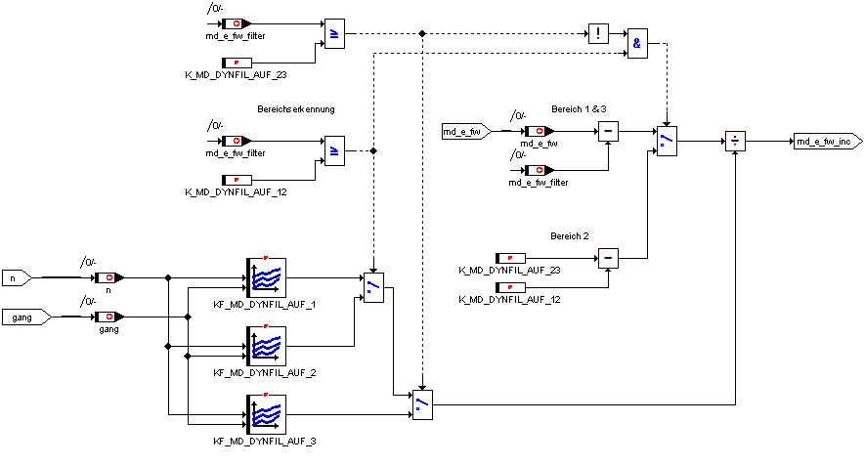

### 7.2.2. Dashpotfilter

**Picture: Dashpot operation of the dynamic filter (md_filter_dashpot.gif)**

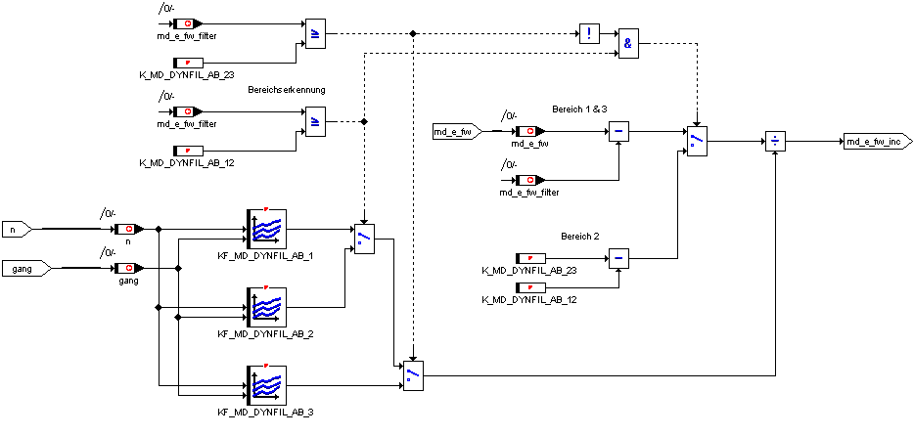

## 7.2. Intervention idle controller

The moment portion of the idle controller is included as shown in the following image.

**Picture: Calculation of the idle controller portion (md_eingrlfr.gif))**

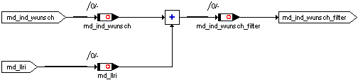

# 8. Moment Limits

An overview of the moment-limiting interventions is shown in the following image. The individual boundaries are described in the following subchapters.

**Picture: Overview Moment Limitation (md_begrenzung.gif))**

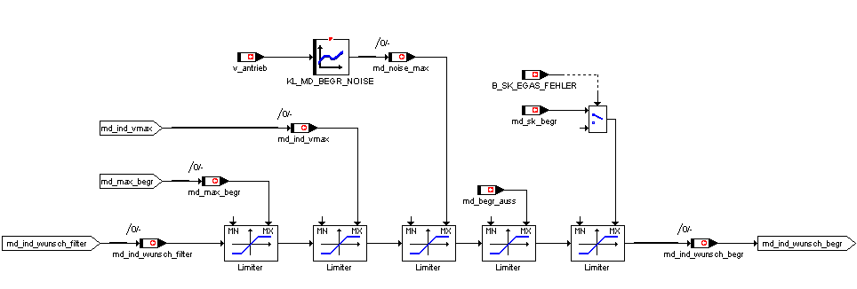

## 8.1. Torque limitation

Due to a too low torque strength of the gearbox, the engine torque (moment at the clutch) must be limited.

The maximum permissible indexed motor torque is calculated from the characteristic "KL_MD_BEGR_GANG", which contains the gear-dependent maximum moments, plus the internal loss moments "md_ind_schlepp". With a positive speed gradient, a further correction is made around the engine moment of inertia. The influence of an ignition angle late adjustment of the knock control or knock adaptation is taken into account via the ignition angle efficiency "md_eta_zw_ve".

md_max_begr = ( KL_MD_BEGR_GANG ( gang )

+ md_ind_schlepp

+ K_MD_J_MOTOR * d_n40if d_n40 > 0

) / md_eta_zw_ve

The torque limitation is intended to prevent only continuous operation of the motor above the maximum torque. A short-term exceedance of the torque limit value, such as in acceleration measurements, is considered to be uncritical for the transmission. The functionality of the torque limitation is adapted to this. Thus, after each force-closing interruption, the torque limitation for the period "K_MD_BEGR_T" becomes inactive, whereby the time only runs from the first exceeding of the maximum threshold. Then, starting from the current desired moment, the limit threshold is adjusted to the target value "md_max_begr" via the "K_MD_BEGR_RAMPE" ramp. After completion of the control, changes to "md_max_begr", which can be very fast due to speed gradients and KR/KA influences, are limited by the change limit "K_MD_BEGR_DELTA".



## 8.2. Speed limit

The Vmax limit acts directly on the EGas system on the MSS60 via the moment manager. The maximum speed is controlled via an I controller in two stages.

**Vmax Standby: v > vmax_berei**

With the first exceeding of "vmax_berei", which must be below the Vmax "K_V_MAX", a torque is calculated in advance, which should enable stationary driving in the Vmax point.

For this purpose, the current indexed moment is corrected around the moment surplus, which currently provides an Fz acceleration and then multiplied by the square quotient from maximum speed to actual speed, since the air resistance also increases squarely with the Fz velocity.

md_ind_vmax = ( md_ind_wunsch_red_korr - K_MD_J_FZ * d_v ) * ( K_V_MAX / v )2

**Vmax control: v > K_V_MAX**

When K_V_MAX, an I-controller becomes active, which integrates the maximum permissible moment "md_max_begr" according to the controller deviation on or off.

md_ind_vmax = md_ind_vmax + K_MD_I_VMAX * ( K_V_MAX - v )

Since due to the I-controller "md_ind_vmax" can be very small or also overflow, "md_ind_vmax" is limited to the values K_MD_VMAX_MIN or K_MD_VMAX_MAX.

The Vmax control is deactivated again as soon as the Fzg speed K_V_MAX below the threshold - K_V_MAX_HYS has fallen.

The consideration of "md_ind_vmax" in the moment manager is only with active Vmax‑limitation, not with Vmax readiness.

## 8.3. Torques in case of cat-damaging dropouts

In the case of cat-damaging dropouts, a torque limitation becomes active, which is to reduce the filling and thus the air flow through the catalyst depending on the current engine speed.

The Drehomenten limit is activated as soon as a cylinder had to be switched off due to cat-damaging dropouts.

Phase 1: Expiration of the waiting time "K_MD_BEGR_AUSS_TIME", in which no moment limits work yet to prevent possible critical driving situations.

Phase 2: Ramp-shaped control with "K_MD_BEGR_AUSS_ABREG", starting from the driver's request "md_ind_wunsch" to the limitation torque.

Phase 3: Torque limitation active.

Calculation of the limiting moment:

md_begr_auss = KL_MD_BEGR_AUSS = f ( n )

The current state of the torque limit is visible in the "md_begr_auss_st" variable.

The torque limitation remains **active until the engine is switched off,**even if no furtherdropouts have been detected in the meantime.

## 8.4. Torques at the breakdown of the krafstoff druck

In the event of a collapse of the fuel pressure and the simultaneous empty tank, a torque limitation becomes active, which is supposed to reduce the filling and thus the air flow through the catalyst depending on the current engine speed.

The torque limitation is activated as soon as the cat protection function sets the activation release based on the four lambda probe signals and the tank level.

Since the engine is no longer running at this time due to the collapsed fuel pressure, torque limitation is done immediately and without control.

Calculation of the limiting moment:

md_begr_auss = KL_MD_BEGR_FST = f ( n )

The current state of the torque limit is also visible in the variable "md_begr_auss_st".

The torque limitation remains **active until the engine is switched off.**

## 8.5. Moment Limitation for Noise Reduction

To minimize the noise, a function is implemented, which limits the maximum indexed moment of the engine after setting the condition noise reduction ( see module description: gang.doc ), depending on the current vehicle speed.

md_noise_max = KL_MD_BEGR_NOISE = f ( v_antrieb )

# 8.8. Moment Reserve

Since the current ignition angles usually correspond to the ignition angle best value, only torque reductions are possible via ignition angle interventions. In certain operating areas, such as idle control, however, it is desirable to be able to quickly build up moments via an ignition angle intervention.

For this purpose, the moment specification for the filling path is increased via the Moment Reserve module, while the moment specification for the ignition angle path remains unchanged. This leads to an increase in the filling and thus the actual moment before intervention. Thus, the actual moment before intervention exceeds the moment requirement of the ignition angle path and the torque excess is compensated by an ignition angle late adjustment. This compensated torque surplus is now available for a quick increase in the number of moments by means of an early adjustment of the ignition angles.

md_res_kath: Moment reserve of the cather function

md_res = md_res_kath

## 8.9. Moment Reserve for Cathesial Function

In the case of the cather function, the moment reserve is used for a deterioration of efficiency and thus for an increase in exhaust gas temperatures.

Depending on the operating state, speed, load, engine temperature and time since start, an offset torque is calculated, which is added to the desired moment for the filling path and compensated again by an ignition angle intervention.

The offset moment is as follows:

md_res_kath = KF_MD_RES_KATHoffset moment = f( n, wi )

* KF_MD_RES_KATH_GEW weighting factor = f( tmot, t_ml )

* md_res_kath_faktor weighting factor on/off

The determination of the weighting factor "md_res_kath_faktor" itself can be divided into five areas:

Area 1: Start or post-start (until control start moment terminated )

Weight ingenuation factor = 0

Area 2: Adjusting the weighting factor

the weighting factor is calculated from the starting value linearly with the increment

"K_MD_RES_KATH_T_AUFREG" to 1.0

Area 3: Moment reserve for cat heating fully active

Weighting factor = 1.0

Area 4: Adjusting the weighting factor

After the "B_KATH_AKTIV_MDRES" condition has been taken away, the weight ingenuity factor is­adjusted linearly with the increment "K_MD_RES_KATH_T_ABREG" to zero.

Area 5: Moment reserve for cat heating inactive

Weight ingenuation factor = 0

The activation condition for the moment reserve cat heating is identical to the activation condition for the ignition angle intervention cat heating.

The moment intervention for cat heaters can be blocked via the constant "K_MD_RES_CONTROL".

**Picture: Overview Moment Reserve for Cat Heaters (md_reservekath.gif))**

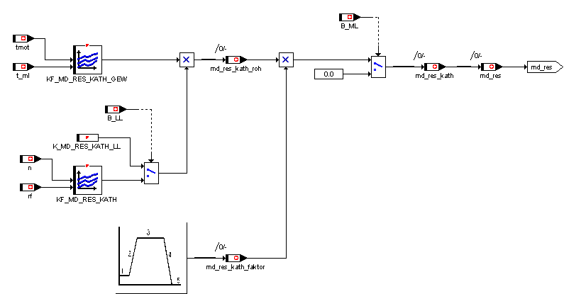

## 8.10. Moment reserve for strong steering impacts (not implemented in EVT!)

When the final stop of the steering is reached, the servo pump of the steering force support absorbs a lot of moment, which can lead to a dip in the engine speed, possibly even to the death of the motor, when idle. The reaction of the idle controller via a filling increase is too slow due to the gas runtime. Therefore, depending on the steering wheel impact, a torque reserve should be built up in advance, which should then allow a rapid increase in the torque via an ignition angle early adjustment when the idle speed is­below.

Activation condition: v < K_MD_RES_LRW_V

Deactivation: v > K_MD_RES_LRW_V + K_MD_RES_LRW_VHYS

Calculation algorithm in key points:

• Amount formation of the steering angle

• Calculation of the raw value of the moment reserve "md_res_lrw_loc" over characteristic curve

KL_MD_RES_LRW = f( lrw_abs )

• Change limitation of the moment reserve to "K_MD_RES_LRW_DELTA"

resulting moment reserve: md_res_lrw_roh

• Take into account any existing ZW late adjustment from the

Cathetic module

md_res_lrw = md_res_lrw_roh - ( md_ind_wunsch_begr * md_eta_kath_offset )

The term md_ind_wunsch_begr * md_eta_kath_offset is the moment in Nm, which is already available as a moment reserve due to the ZW late drawing of the cathetic function. A possible parallel moment reserve for steering support must therefore only take into account the delta.

The status of the torque reserve is visible in the variable "md_res_lrw_st":

Bit 0: Activation conditions met

Bit 1: Intervention active, i.e. non-zero intervention moment

## 8.11. Limitation of the moment reserve

The working principle of the moment reserve presupposes that the moment increase in the filling path can be compensated by an ignition angle intervention. To this end, it must be determined how much room for manoeuvre is still available for a moment reserve in the current operating point.

The remaining margin for an ignition angle late adjustment is the difference between the current ( "md_eta_zw_ve" ) and the minimum possible ( "md_eta_zw_min" ) ZW efficiency.

The possible factor for an increase in the fill target is calculated as follows:

"md_eta_res" = 1 / (1 - ( md_eta_zw_ve - md_eta_zw_min ))

If the requested moment reserve exceeds this margin, the moment request is limited to the value "md_ind_wunsch_begr * md_eta_res".

# 9. Moment intervention filling path

In this module, the moment coordination is carried out with the DSC system as well as with the other moment-reducing modules.

The system has two different intervention options. In the case of an MSR intervention (motor towing torque control ) the DSC requests a torque increase, which is adjusted purely via the filling. In the case of an ASC intervention (automatic stability control ), the ASC system can‑request torque reductions separately for the filling and ignition angle path.

The plausibility of the DSC interface as well as the conversion of the requirements into indexed moments is described in the chapter "CAN-Interface", so that at this point only the two intervention moments "md_ind_asc_lm_abs" and "md_ind_msr_abs" are considered.

The requested moment interventions are taken into account via Max and Min selections with respect to the desired moment "md_ind_wunsch_red". The order of selection is described in the following graphic.

**Picture: Moment interventions in fill path (md_fuellung.gif)**

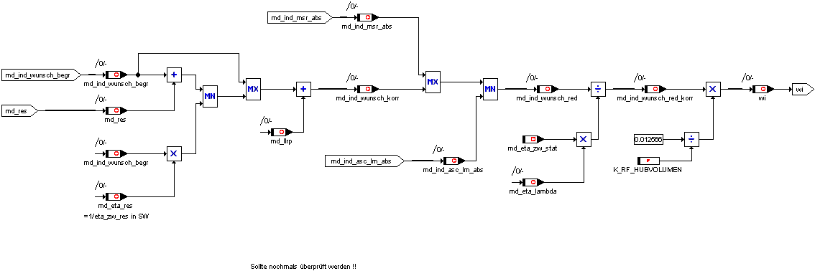

## 10. Efficiency Correction

A big distribution of the moment manager is that it can easily compensate for moment-influencing actions of other modules such as lean warm-up or cat heating

Thus, the influence of a stationary ignition angle late adjustment and a conscious deterioration in efficiency for the catheterfunction function in the ignition angle efficiency "md_eta_zw_stat" is calculated and the resulting loss of moments is compensated at this point by a filling correction.

Likewise, the influence of the lambda value on the moment release is recorded in a lambda efficiency "md_eta_lambda" and compensated by a filling correction. However, only lambda efficiency of small "K_MD_ETA_LAMBDA_MAX" is taken into account. Efficiencies greater of this value are limited to this value.

The new moment request is thus composed as follows:

md_ind_wunsch_red_korr = md_ind_wunsch_red

/ md_eta_zw_stat

/ md_eta_lambda

The efficiency correction can also be deactivated for application purposes via the constant "K_MD_ETA_MCS".

Bit 0 = 1 : Correction via Lambda active

Bit 1 = 1 : Correction via stationary ignition angle incl. cathesity efficiency active

Bit 7 = 1 : Correction only active via cather efficiency, but not via stationary angle

## 10. Calculation of wi

The specific, indexed work "wi" is calculated from the indexed, corrected desired moment "md_ind_wunsch_red_korr". "Wi" is used as input size for various characteristic fields (e.g. control edges) and has the advantage that it contains the stroke volume and is therefore independent of the displacement variant.

The corresponding formula is:



# 14. Calculation of the control edges

In the EVT motor, the filling is not realized by the throttle angle, but by the control edges. In this module (Evt_momentenrealisierung.doc and Modemanager.doc) the target throttle angle for 50 mbar vacuum for tank ventilation, the base ignition angle, the target air mass flow and the pre-storage angle are calculated in addition to the control edges.

# 14. Moment intervention ignition path

The DSC moment intervention in the ignition angle path is analogous to the fill path via a maximum value ( MSR function ) or a minimum value selection ( ASC function ). The idle control also has a moment-md_llr_tz + md_llrp intervention, which only affects the ZW path of the moment manager and which can counteract moment-reducing measures of other modules. The output size "md_tz_red" is limited to positive moments.

**Picture: DSC and LLR moment interference in ignition angle path (dsc_llr_mdeingriff_zw.gif)**

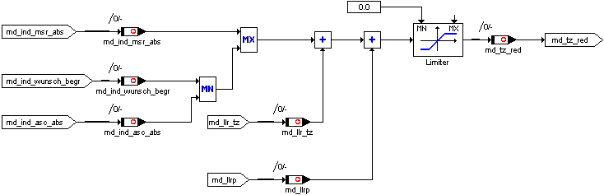

# 15. Calculation of ignition angle interference

In this module, the moment requested for the ignition angle path is converted into an intervention ignition angle, taking into account the actual ignition angles of the individual cylinders.

The conversion takes place cylinder-selectively once per working game about 360 degrees before the ignition OT of the corresponding cylinder. This is to guarantee that on the one hand the ignition angle interventions of the knock control are already available, on the other hand there is still enough time to update the ignition channel before the defueling of the ignition coil.

## Calculation of optimal ignition angles

The optimal ignition angle zw_opt is the ignition angle at which the ignition hook has its vertex, i.e. the indexed engine torque/work reaches its maximum value under normal conditions. The theoretically optimal ignition angle may lie earlier than the ignition angle that can be driven in the corresponding operating point. This ignition angle is the reference for the calculation of the ignition angle interventions in the moment manager.

The calculation of the indexed actual and target wi is related to this optimal ignition angle. For each EVT operating mode, there must be a characteristic field for the optimum ignition angle.

(1) zw_opt = KF_ZW_OPT_x( n, wi )

with x = 0, 1, 2, 3, 4, 5, 7, 11, 12 (operating modes bm_evt_state)

In the corrected optimal ignition angle zw_opt_korr the influence of the engine temperature and the lambda value is still taken into account.

(2) zw_opt_korr =zw_opt + KF_ZW_TMOT( tmot,wi) + zw_lambda

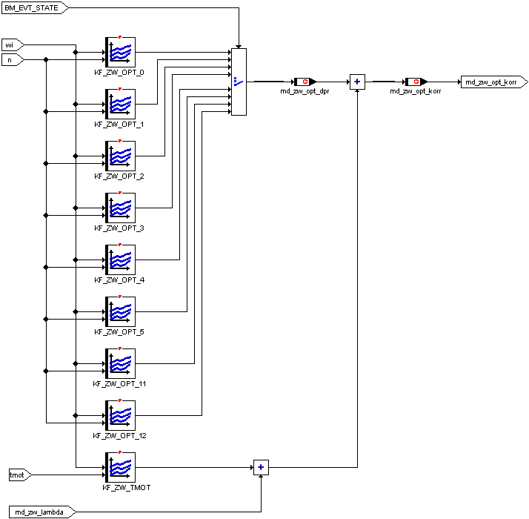

**Picture: Calculation of optimal ZW (ZW_Eingriff2_2.gif)**

## Calculation of ignition angle efficiency levels

The ignition angle efficiency levels are required to take into account existing ignition angle interventions when calculating the actual wi. Furthermore, the existing adjustment range for ignition angle interventions of the moment manager is calculated via the ignition angle efficiency.

### 14.2.1. minimum ignition angle efficiency

The size "md_eta_zw_min" includes the efficiency that can be achieved with the latest permitted ignition time "tz_min". Wi-reductions below this efficiency are not fully representable by ignition angle interventions:

(1) md_eta_zw_min = Fkt.(Zündhaken_Polynom(tz_min))

## Base ignition angle efficiency

The size "eta_zw_bas" includes the efficiency, which is achieved with the current, corrected base ignition angle "tz_bas_korr". The corrected base ignition angle consists of the ignition angle basic characteristic fields of the operating modes, a correction over engine temperature and an ignition angle offset by lambda variation.

(2) tz_bas_korr =tz_bas + tz_tkorr + md_zw_lambda

The ground ignition angle tz_bas is calculated in the Moment Realization module.

With active cat heating, the basic efficiency is reduced by the amount "eta_zw_kath_offset".

(3) eta_zw_bas = Fkt.(Zündhaken_Polynom tz_bas_korr)) - eta_zw_kath_offset

### 14.2.3. Calculation of ignition angle efficiency before intervention

The sizes "eta_veX" are based on the calculated ignition angles before intervention "tz_veX", in which adjustments from knock control, knock adaptation and dynamic retention are also included. Since the individual ignition angles are cylinder-selective, the efficiency must also be calculated cylinder-selectively.

(4) eta_zw_ve[x] = Fkt.(Zündhaken_Polynom(tz_ve[x]))

with x = 1, ..., number of cylinders

(5) eta_zw_ve = Mean (md_eta_zw_ve[x])

with x = 1, ..., number of cylinders

## 14.2.4. Calculation of ignition angle efficiency after intervention

First, the segment-synchronous moment intervention of the anti-ruckel control "md_ar" is added to the desired moment "md_tz_red". This procedure can normally only have a negative effect. However, with an active torque reserve, it can also build up moment.

From the new target moment, a target efficiency "md_eta_zw_soll" is calculated by division with a reference torque, which is the measure for the ignition angle intervention. However, the implementation for six- and eight-cylinders differs in the type of reference torque, so that the selection is configurable by means of the constants "K_MD_BEZUG_ZW".

K_MD_BEZUG_ZW = actual moment:

For all ZW interventions, the actual moment calculated from speed and relative filling is used as the reference moment.

K_MD_BEZUG_ZW = Target moment:

In the case of active DSC interventions or in the case of egas faults, the actual moment is also used as a reference moment. For all other interventions, the reference torque corresponds to the target‑moment for the filling path. As a result, regardless of the setting accuracy of the egas system and all dynamic influences, only the difference between the filling and ZW specifications is relevant for the ZW intervention.

The value averaged by the cylinders:

(6) eta_zw_ne = Mean (md_eta_zw_ne[x])

with x = 1, ..., number of cylinders

In the case of ZW interventions due to DSC requirements or in the Egas emergency program, the number of cylinders currently hidden is taken into account in the reference moment.

If the requirement to guarantee a minimum ZW efficiency deterioration for the cathetic function in all operating points, the calculated target efficiency upwards is limited to the cathetic efficiency eta_kath.

The subsequent limitation to "eta_zw_min" ensures that the ignition angle interventions are limited to the latest possible ignition angle.

By means of the constants "K_ETA_EINGRIFF" a minimally required efficiency for the ignition angle intervention can be defined, i.e. an intervention is only carried out if it falls below this value. In the variable "st_tz" represents one bit of a cylinder ( bit 0 = cylinder 1 ), wherein a set bit means that at the moment for this cylinder an ignition angle intervention by the moment manager is active.

Finally, a plausibility is carried out in relation to the ignition angle efficiency before intervention.

### 14.2.5. Calculation of interference ignition angle

The calculated cylinder-selective ignition angle efficiency after intervention eta_zw_ne[x] must now be converted in a second stage into an absolute angle of intervention related to the ignition OT.

This is done via the ignition hook deposited for this operating point, which indicates the ignition angle efficiency depending on the angle difference to the optimum ignition angle. In this case, however, there is an efficiency and an ignition angle is to be calculated, which is achieved by a reversal of the calculation algorithm. An ignition hook parabola thus becomes an efficiency root.

**Parabolic equation: y =**   **a x2** + b x **+ 1**

**Root equation: **

The result of the root equation is an offset ignition angle to the optimal ignition angle "zw_opt_korr", for which the ignition hook is stored.

The switch at the end of the calculation can be used to decide when an angle of intervention should be passed on to the ignition angle calculation. Behind the switch B_ZÜNDEINGRIFF are the following conditions of intervention:

ASC - Intervention

or MSR - intervention

or (Egas emergency program level 3 or 4 active ?? Siko EVT??)

or cathesing function active

or dynamic filter active due to SA/WE

or dynamic filter due to load impact / Dashpot active

or moment reserve active

or anti-ruckel control active

or idle stabilization via ignition angle stake active

or generally activated via K_MD_TZ_CONTROL

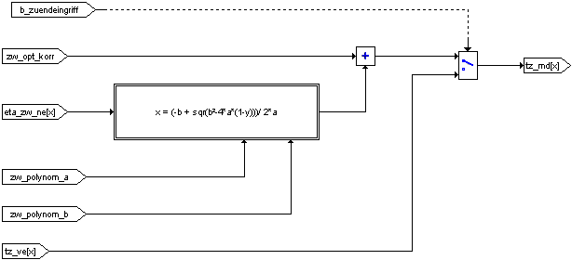

**Picture: Calculation of ignition angle efficiency after intervention (ZW_Eingriff_13_1.gif)**

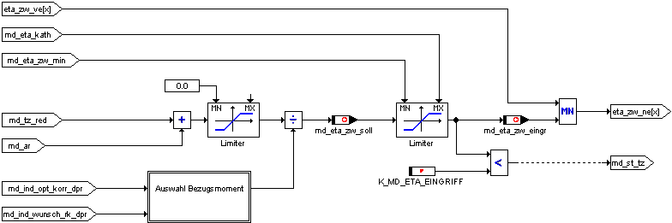

**Picture: Calculation of the intervention ignition angle (ZW_Eingriff_13_2.gif)**

## Calculation Standardized ignition hooks

The calculation of the ignition angle efficiency and the intervention ignition angle of the moment manager is based on the standardized ignition hooks. For this purpose, speed- and wi-dependent standard ignition hooks are stored.

The speed- and wi-dependent standard ignition hooks are replaced by the parameters a and b of the parabolic equation

(1) y = ax2 + bx + 1

Described.

The parable is always open downwards, so that the parameter a must always be negative. The input value x represents the difference between the optimal, corrected ignition angle and the ignition angle to be considered. Since the ignition angle output is limited to the minimum permitted ignition angle "zw_min", the ignition angles are also limited to this value within the ignition hook calculation.

The output value y represents the ignition angle efficiency, which can only reach 1.0 at an input value of zero (no infinitely flat ignition hooks). The initial value is therefore always between the possible efficiency for the "zw_min" and 1.0.

If one substitutes the general variables in Gl.(1) with the equivalent labels, the following follows:

(2) eta_zw_x = zw_polynom_a * (dzw_x)2 + zw_polynom_b*dzw_x + 1

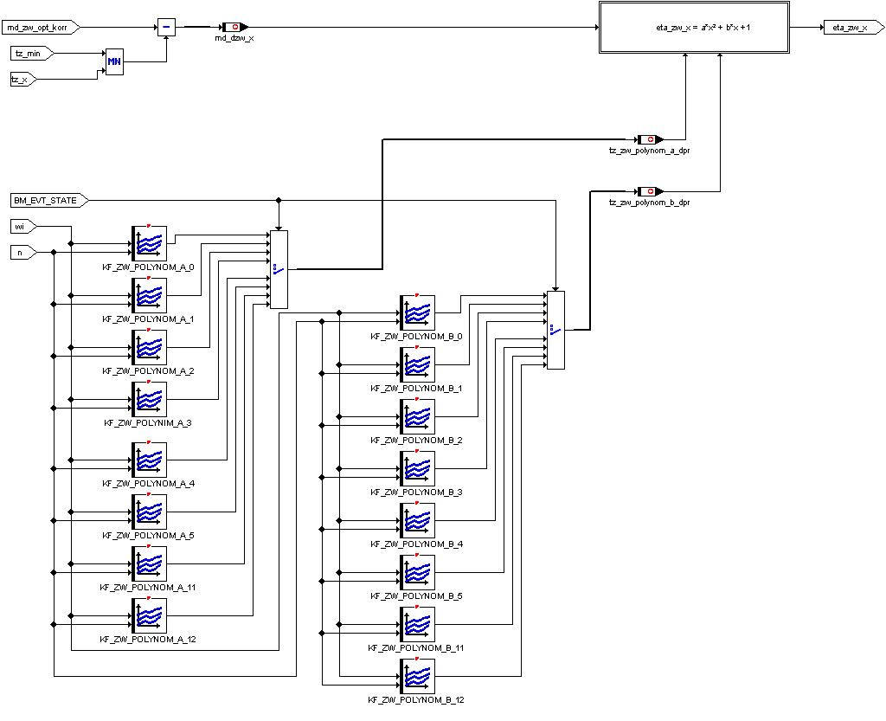

**Picture: Calculation of standardized ignition hooks (ZW_Eingriff2_3.gif)**

# 16. Monitoring Moment Calculation

## 16.1. Hedge Moments Calculation

The main path of the moment calculation and all offset moments of other modules acting on it are checked for plausibility within the moment manager. If an implausible value is detected, that value is immediately converted to a neutral value and an error filter is started. After the fault filtering has expired, the egas monitoring function is notified, which then switches the egas system to emergency running stage 2 - emergency travel via the idle system.

In the case of efficiency corrections ( ignition angle, lambda ) within the moment manager only a limitation of the efficiency downwards, but no error entry or change in an emergency program, since it cannot be excluded that in normal operation the limit value can be exceeded.

**Security queries (error conditions):**

• Motor towing torque "md_e_schlepp_hyp" < maximum effective motor torque "md_e_max"

• Loss moment of the motor "md_e_schlepp" > "K_MD_SK_MAX_MDMIN" and speed threshold "n" > "K_MD_SK_N_MDMIN"

• Output MD dynamic filter > Maximum torque "K_MD_SK_MAX"

• resulting desired moment "md_ind_wunsch_red_korr" > "K_MD_SK_MAX"

• Lambda weight loss factor > 2 ( overflow )

**Monitoring moment interventions**

• Intervention I-part of the idle control "md_llri" > Maximum intervention "K_MD_SK_LLR_MAX"

• Intervention PD part of the idle control "md_llrp" > Maximum intervention "K_MD_SK_LLR_MAX"

## 

## 16.2. Monitoring Target moment to actual moment

It is very difficult to plausibly plausibly the actual torque of the engine to the driver's desired moment over the entire operating range, since in this case a large number of input parameters, all stationary states, as well as all moment interventions of other modules would have to be taken into account. This would require that almost the entire calculation path be redundantly stored again, which is not possible due to lack of resources, or that the corresponding tolerance limits would have to be greatly expanded.

Therefore, two moment monitoring functions were implemented in the MSS60. A function that compares the actual moment with the desired moment taking into account all moment interventions and has more than defined tolerance limits. And via a moment monitoring, which is limited to a zero torque specification of the driver ( PWG = zero ), but is switched accordingly sharply there. This has the advantage that in this operating point the moment calculation can be estimated much better, and thus the tolerance limit can be tightened. Furthermore, it can be assumed that if the engine eats an undesirably high moment, the driver will automatically go off the gas and thus meet the activation conditions for this test.

### 16.2.1. Monitoring of target/actual moment over entire operating range

Definition of actual moment md_sk_vergl_ist =

md_ind_ne actual indexed actual moment of the motor generated, determined from characteristic field over speed and load and ZW efficiency taking into account all interventions

Definition of the target moment md_sk_vergl_soll =

md_e_fw_filter filtered driver's desired moment from PWG position or speed controller

- md_e_schlepp towing torque of the engine incl. all consumers

+ md_ar moment of intervention of the anti-ruckel regulation

+ md_llri moment of intervention of the I-controller of the idle control

+ md_llrp moment of intervention of the P-controller of the idle control

In the case of a moment-increasing MSR intervention, the maximum of the request moment and "md_sk_vergl_soll" is used as the target moment.

If the actual moment of the motor exceeds the target torque for the period "K_MD_SK_TIMER_MD" by the amount K_MD_SK_OFFSET + ( 1 - K_MD_SK_GEWICHTUNG ) * md_sk_vergl_ist, an error in the egas system is closed and a change to the emergency program 2 - driving via the idle system.

The monitoring is active in the "Motor running" operating state.

### 16.2.2. Monitoring Target/actual moment at PWG specification = 0

Activation condition for monitoring

Operating state motor running

No FGR operation

no MSR intervention

Dashpot function of the dynamic filter is controlled

Pedal value specification <= K_MD_SK_PWGMIN

Motor speed > Idle set-up speed + K_MD_SK_NHYS

If in this case the calculated driver request moment exceeds the value "K_MD_SK_FWMAX" or the calculated DK target position the value "KL_MD_SK_WDK" for the period "K_MD_SK_TIMER", an error in the moment calculation is closed and the egas system also switches to the emergency program of level 2.

## 17. Partial firing for open clamping throttle valves

In the case of open-clamping throttle valves, the filling calculated by the Moment Manager can­no longer be implemented by default, as the throttle valve system is no longer responding. However, in order to be able to continue to control the torque output of the engine, the moment manager must use another possibility of intervention in the generation of moments - the injection.

For this purpose, a degree of fade-out "md_sk_verh" is calculated based on the desired moment and the current actual moment of the motor, taking into account the possible ignition angle interventions in this operating­point. If this efficiency falls below the value one, this means that the desired motor torque can no longer be reduced by ignition angle interventions alone. Therefore, a fade-out stage "md_sk_tired" is calculated, which corresponds to the number of active cylinders and switches off the unnecessary cylinders after a predefined fade-out pattern.

The injection is carried out via the variable "md_sk_ti_st", where by each cylinder is represented by a bit. If the bit is set, this means that the corresponding cylinder may be active. If the bit is deleted, the cylinder must be switched off.

**Overview: Partial firing (partial firing.gif)**

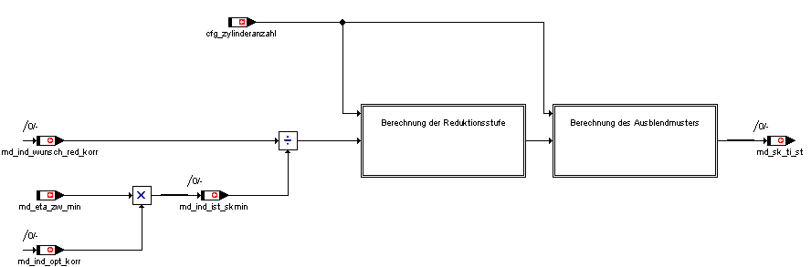

In the Partial Firing module, there are two applicationable constants that are not visible in the overview screen. The constant "K_MD_SK_TIRED_HYS" can be used to adjust a hysteresis for the efficiency, which acts between fading out and fading. The K_MD_SK_TIRED_MIN constant defines the number of cylinders that must be at least active. If a reduction level below this value is required, all cylinders are hidden.

# 18. Applicationable data from the Moment Manager

|  |  |
| --- | --- |
| **Name** | **Importance** |
| K_MD_ASC_BEGR | Minimum moment for ASC intervention |
| K_MD_ASC_CONTROL | Tax bytes to activate ASC interventions |
| K_MD_BEGR_AUSS_ABREG | Control ramp for moment limitation in case of cat-damaging dropouts |
| K_MD_BEGR_AUSS_TIME | Waiting time to moment limitation for cat-damaging dropouts |
| K_MD_BEGR_DELTA | Change limit for moment limit |
| K_MD_BEGR_RAMPE | Control ramp for moment limitation |
| K_MD_BEGR_T | Delay time for moment limit |
| K_MD_BEZUG_ZW | Selection for reference torque ZW intervention (control byte ZW interventions) |
| K_MD_DELTA_SA_HARD | Step-width Md-filter for hard SA |
| K_MD_DELTA_SA_SOFT | Step-width Md-filter at soft SA |
| K_MD_ETA_EINGRIFF | ZW efficiency below which an ignition angle intervention is only activated |
| K_MD_ETA_LAMBDA_MAX | maximum lambda efficiency for filling correction |
| K_MD_ETA_MCS | Configuration parameters for consideration md_eta_zw_stat |
| K_MD_ETA_STAT_TAU | Filter time constant for station. ZW efficiency |
| K_MD_I_VMAX | Integrator step width for the Vmax control over moment |
| K_MD_J_FZ | Mass inertia vehicle Nm/s2 |
| K_MD_J_MOTOR | Mass inertia motor Nm/s2 |
| K_MD_MIN_KKOS_AUS_FILTER | Filter time constant for compressor shutdown |
| K_MD_MIN_KKOS_FILTER | Filter time constant for compressor switching |
| K_MD_MIN_KKOS_START | Factor for filter initial value-exaggeration Compressor connection |
| K_MD_MIN_START_FILTER | Filter time constant for start torque control |
| K_MD_MIN_VERH_KRAFTS | Limitation of MDmin hyperbole at force |
| K_MD_MIN_VERH_NO_KRAFTS | Limitation of MDmin hyperbole without force |
| K_MD_MIN_VERH_START | Limitation of MDmin hyperbole during startup |
| K_MD_MSR_BEGR | Maximum moment for MSR request |
| K_MD_NORM | Standard moment for CAN interface |
| K_MD_POLYNOM_A_LL | A-Polynomium for ignition hook calculation at LL |
| K_MD_POLYNOM_B_LL | B-polynomial for ignition hook calculation at LL |
| K_MD_RES_CONTROL | Control byte moment reserve |
| K_MD_RES_KATH_LL | Md-Reserve for cat heating in the LL |
| K_MD_RES_KATH_START | Starting value Md-Reserve for cat heaters |
| K_MD_RES_KATH_T_ABREG | Control ramp for moment reserve cat heating |
| K_MD_RES_KATH_T_AUFREG | Control ramp for moment reserve cat heating |
| K_MD_SK_AX_IMIN | Minvalue I-regulator for acceleration limitation in the Egas emergency program |
| K_MD_SK_ETA_MIN | Min value for ZW efficiencies |
| K_MD_SK_FWMAX | maximum permissible md_fw_rel at pwg = 0 |
| K_MD_SK_GEWICHTUNG | Weighting factor target to actual moment for moment monitoring |
| K_MD_SK_LLR_MAX | maximum permissible moment of intervention of the idle control |
| K_MD_SK_MAX | maximum indexed moment within the moment calculation |
| K_MD_SK_MAX_MDMIN | max. permissible md_ind_min |
| K_MD_SK_N_MDMIN | Speed threshold for md_min monitoring |
| K_MD_SK_NHYS | Speed offset on llr_nsoll for monitoring Md-zero specification |
| K_MD_SK_OFFSET | Offset for monitoring Target to actual moment |
| K_MD_SK_PWGMIN | PWG threshold active below Md-zero target |
| K_MD_SK_TIMER | Filter time for monitoring Md-zero default |
| K_MD_SK_TIMER_MD | Filter time for monitoring Target/actual moment |
| K_MD_SK_TIRED_HYS | Hysteresis for fade-out efficiency in partial firing |
| K_MD_SK_TIRED_MIN | min. Number of cylinders still active in partial firing |
| K_MD_STAT_ASC | Test parameters for status feedback DSC intervention |
| K_MD_TZ_CONTROL | Control bytes for the moment manager's ignition angle interventions |
| K_MD_TZMIN_HYS | ZW-Hysterse for SA-Triggering |
| K_MD_VMAX_MAX | Minimum torque for I-controller Vmax limitation |
| K_MD_VMAX_MIN | Maximum torque for I-controller Vmax limit |
| K_V_MAX | V-Activation Threshold for Vmax Limitation |
| K_V_MAX_HYS | V-hysteresis for Vmax limitation |
| KF_MD_FAHRER | relative target moment from pwg_soll and n |
| KF_MD_LAMBDA | Lambda actual value for inactive lambda controller = f (n, wi) e.g. warm-up |
| KF_MD_MAX_MD_IND_OPT | Moment characteristic field of the motor = f ( n, wi )  determined under standard conditions |
| KF_MD_MIN_BRENN | maximum negative distance to the towing torque of the engine in fired mode = f (n, tmot) |
| KF_MD_MIN_REIB_DIFF | Friction torque difference to standard temperature = f (tmot, toel) |
| KF_MD_MIN_START | additional offset moment during start = f (n, tmot) |
| KF_MD_POLYNOM_A | Parameter f. square term of the ignition hook parabola =f(n,wi) |
| KF_MD_POLYNOM_B | Parameters for linear term of the ignition hook hyperbole = f (n, wi) |
| KF_MD_RES_KATH | Offset moment for moment reserve cat heating f (n, wi) |
| KF_MD_RES_KATH_GEW | Weighting factor for moment reserve cat heating f (tmot, t_ml) |
| KF_MD_WE | Onrule ramp moment for reinstatement |
| KF_MD_ZW_OPT | Ignition angle best = f (n, wi) |
| KL_MD_BEGR_AUSS | Moment limit = f (n) for cat-damaging dropouts |
| KL_MD_BEGR_FST | Moment limit = f (n) when tank is empty |
| KL_MD_BEGR_GANG | gangabh. Maximum moment = f (gang) |
| KL_MD_BEGR_NOISE | Moment limit = f (v) for noise limitation |
| KL_MD_LS_W_GANG | Gear weighting of time constants for MD dynamic filters |
| KL_MD_MIN_DN_HYP | Speed offset for MDmin hyperbole = f (tmot) |
| KL_MD_MIN_REIB_ABREG | Control ramp friction torque offset after start = f (tmot) |
| KL_MD_MIN_REIB_OFFSET | Friction moment after start = f (tmot) |
| KL_MD_SK_AX | maximum permissible Fz acceleration in the emergency program |
| KL_MD_SK_AX_GANG | Gear weighting for acceleration limitation |
| KL_MD_SK_AX_INEG | I-parameter for acceleration limitation |
| KL_MD_SK_AX_IPOS | I-parameter for acceleration limitation |
| KL_MD_SK_AX_P | P-parameter for acceleration limitation |
| KL_MD_SK_GRAD | Ramp of transition function at Md-limitation |
| KL_MD_SK_MAX | max. engine torque in the Egas emergency program |
| KL_MD_SK_WDK | maximum permissible DK position at Md-zero default f (n) |
| KL_MD_W_GANG_DASHPOT | Gangabh. Weight ingenuity factor for MD dynamic filter DASHPOT |
| KL_MD_WURZEL | Root characteristic for reverse calculation of the ignition hook parabola |
| KL_MD_ZW_LA | Influence of the lambda value on ignition angle best = f (la) |
| KL_MD_ZW_TMOT | Influence of the engine temperature on ignition angle best = f (tmot) |
| KL_V_MAX_GANG | gear-dependent maximum speed |
| KL_V_MAX_SK | Maximum speed for egas emergency program levels |

# 19. Variables of the Moment Manager

|  |  |
| --- | --- |
| **Name** | **Importance** |
| can_kkos_lm | Load torque air-conditioning compressor from CAN |
| eta_nex x = 1 .. 8 | cylinder-selective ZW efficiencies after ZW interventions of the MM |
| eta_vex x = 1 .. 8 | cylinder-selective ZW efficiencies before ZW interventions of the MM |
| md_ar | AR intervention |
| md_begr_auss | Limitation moment in case of cat-damaging dropouts or empty tank |
| md_begr_auss_st | Status of torque limitation in case of cat-damaging dropouts or empty tank |
| md_begr_st | Status of torque limitation |
| md_begr_t | Waiting time to activation Torque limitation |
| md_dyn_ausg | Initial value of the MD dynamic filter |
| md_dyn_st | Status of the MD dynamic filter |
| md_eta_ausblend | Fade-effect |
| md_eta_kath | Target efficiency of cat heating |
| md_eta_lambda | Lambda efficiency |
| md_eta_res | Factor for increasing the filling target for moment reserve |
| md_eta_zw_eingr | ZW target efficiency before intervention |
| md_eta_zw_min | ZW efficiency for the latest possible ignition angle |
| md_eta_zw_ne | Mean value ZW efficiency over all cylinders after moment intervention |
| md_eta_zw_soll | Target efficiency before intervention |
| md_eta_zw_stat | ZW efficiency for stationary ignition angles |
| md_eta_zw_ve | Mean value ZW efficiency over all cylinders before moment intervention |
| md_e_fw | Desired moment driver/FGR effective |
| md_fw_filter | filtered desired moment driver/FGR |
| md_fw_rel | relative driver's wish moment |
| md_ind_asc | Moment intervention ASC |
| md_ind_asc_abs | indexed moment for ASC ignition angle intervention |
| md_ind_asc_lm | Moment intervention ASC over filling |
| md_ind_asc_lm_abs | indexed moment for ASC filling intervention |
| md_ind_fgr | Desired moment from FGR |
| md_ind_ist | Driver's moment without interventions / corrections |
| md_ind_ist_skmin | minimally achievable actual moment at tz_min |
| md_ind_lm_ist | Desired moment with moment limits |
| md_ind_max | maximum indexed moment |
| md_ind_msr | Moment intervention MSR |
| md_ind_msr_abs | indexed moment for MSR filling intervention |
| md_ind_ne | Actual moment incl. ignition angle interventions of the moment manager |
| md_ind_ne_ist | determined indexed moment incl. all interventions |
| md_ind_opt | maximum actual moment under standard conditions |
| md_ind_opt_korr | maximum actual moment under the current conditions |
| md_e_schlepp | Drag torque effective of the motor |
| md_ind_ve | Actual moment without ignition angle interventions of the moment manager |
| md_e_verbraucher | Moment of loss effectively by consumers |
| md_ind_vmax | maximum moment with Vmax limitation |
| md_ind_wunsch | indexed desired moment from the driver / FGR |
| md_ind_wunsch_begr | limited moment of desire |
| md_ind_wunsch_filter | =md_ind_wunsch + md_llri (there is not in Gredi but SW) |
| md_ind_wunsch_korr | Desired moment for filling path after 1st correction stage |
| md_ind_wunsch_red | Desired moment for filling path after 2nd correction stage |
| md_ind_wunsch_red_korr | Desired moment for filling path after 3rd correction stage |
| md_kr_dtz_mittel | medium ZW late draw per cylinder made of KR/KA |
| md_ksg | KSG Actual Moment |
| md_ksg_filter | KSG Actual Moment Filtered |
| md_llr_tz | TZ share of the LFR |
| md_llra | Adaptation share of the LFR |
| md_llra_ko | Adaptation share of the LFR in B_KO |
| md_llri | I share of lFR |
| md_llrp | P-share of the LFR |
| md_ls_kf | Input value for LS filters |
| md_max_begr | maximum allowed indexed motor torque |
| md_mcs_zyl | Calculation ignition angle intervention for cylinder x active |
| md_min_dn_hyp | Speed offset for calculation MDmin hyperbole |
| md_min_start | Offset moment for start |
| md_noise_max | Limitation of the indexed moment, to reduce the noise (not in Gredi) |
| md_norm | Reference moment for CAN interface |
| md_norm_can | Standardization reference for moment interface |
| md_polynom_a | current parameter for quadr. Term of the ignition hook parabola |
| md_polynom_b | current parameter for linear term of the ignition hook parabola |
| md_reib | determined friction moment |
| md_reib_abreg | Step-wide control of friction torque |
| md_reib_offset | Offset friction torque |
| md_res | currently effective moment reserve |
| md_res_kath | Moment reserve for cat heating |
| md_res_kath_faktor | Off/control factor moment reserve cat heating |
| md_res_kath_roh | Raw value moment reserve for cat heating |
| md_sawe_filter | filtered desired moment SAWE |
| md_sawe_verh | Start time of the load impact filter |
| md_sk_begr | Maximum torque MD-SK |
| md_sk_ti_st | Release mask for injection channels |
| md_sk_tired | Number of released injection channels |
| md_sk_vergl_ist | Actual moment in MD monitoring |
| md_sk_vergl_soll | Target moment in MD monitoring |
| md_sk_verh | Ratio of target torque to min. Actual moment |
| md_st | Status byte Moment Manager |
| md_st_eingriff | Status Moment Intervention |
| md_st_tz | Status byte End Angle Intervention Moment Manager |
| md_tz_red | Moment setting tz intervention |
| md_wunsch_rel | relative wish moment driver/FGR |
| md_zw_lambda | Lambda compensation of optimal ignition angles not in Gredi |
| md_zw_opt | Optimum ignition angle |
| md_zw_opt_korr | Ignition angle best value under current conditions |
| md_motor | motor torque delivered to clutch incl. all interventions  =md_ind_ne - md_e_schlepp |
| Wi | specific indexed work [kJ/dm3] |